Vaccination_Data.R

AJAS AJ7

2021-09-26

# vaccination data:  
  
library(ggplot2)

## Warning: package 'ggplot2' was built under R version 4.1.1

library(dplyr)

## Warning: package 'dplyr' was built under R version 4.1.1

##   
## Attaching package: 'dplyr'

## The following objects are masked from 'package:stats':  
##   
## filter, lag

## The following objects are masked from 'package:base':  
##   
## intersect, setdiff, setequal, union

library(choroplethr)

## Warning: package 'choroplethr' was built under R version 4.1.1

## Loading required package: acs

## Warning: package 'acs' was built under R version 4.1.1

## Loading required package: stringr

## Warning: package 'stringr' was built under R version 4.1.1

## Loading required package: XML

## Warning: package 'XML' was built under R version 4.1.1

##   
## Attaching package: 'acs'

## The following object is masked from 'package:dplyr':  
##   
## combine

## The following object is masked from 'package:base':  
##   
## apply

library(choroplethrMaps)

## Warning: package 'choroplethrMaps' was built under R version 4.1.1

library(openintro)

## Warning: package 'openintro' was built under R version 4.1.1

## Loading required package: airports

## Warning: package 'airports' was built under R version 4.1.1

## Loading required package: cherryblossom

## Warning: package 'cherryblossom' was built under R version 4.1.1

## Loading required package: usdata

## Warning: package 'usdata' was built under R version 4.1.1

library(tidyverse)

## Warning: package 'tidyverse' was built under R version 4.1.1

## -- Attaching packages --------------------------------------- tidyverse 1.3.1 --

## v tibble 3.1.4 v purrr 0.3.4  
## v tidyr 1.1.3 v forcats 0.5.1  
## v readr 2.0.1

## Warning: package 'tibble' was built under R version 4.1.1

## Warning: package 'tidyr' was built under R version 4.1.1

## Warning: package 'readr' was built under R version 4.1.1

## Warning: package 'purrr' was built under R version 4.1.1

## Warning: package 'forcats' was built under R version 4.1.1

## -- Conflicts ------------------------------------------ tidyverse_conflicts() --  
## x acs::combine() masks dplyr::combine()  
## x dplyr::filter() masks stats::filter()  
## x dplyr::lag() masks stats::lag()

library(scales)

## Warning: package 'scales' was built under R version 4.1.1

##   
## Attaching package: 'scales'

## The following object is masked from 'package:purrr':  
##   
## discard

## The following object is masked from 'package:readr':  
##   
## col_factor

library(corrgram)

## Warning: package 'corrgram' was built under R version 4.1.1

print(getwd)

## function ()   
## .Internal(getwd())  
## <bytecode: 0x00000000120ddc28>  
## <environment: namespace:base>

# read the dataset named vaccination data  
d<-read.csv("C:/Users/Sumi/vaccination_data_latest.csv")  
print(d)

## State Total.Cases Active Discharged  
## 1 Andaman And Nicobar 7541 4 7408  
## 2 Andhra Pradesh 1978350 20593 1944267  
## 3 Arunachal Pradesh 49668 3032 46399  
## 4 Assam 572546 11719 555470  
## 5 Bihar 725122 357 715119  
## 6 Chandigarh 61970 27 61132  
## 7 Chhattisgarh 1002958 1780 987642  
## 8 Dadra And Nagar Haveli And Daman And Diu 10652 12 10636  
## 9 Delhi 1436623 516 1411042  
## 10 Goa 171705 992 167556  
## 11 Gujarat 825001 204 814720  
## 12 Haryana 770042 690 759705  
## 13 Himachal Pradesh 207344 1727 202084  
## 14 Jammu And Kashmir 322286 1404 316496  
## 15 Jharkhand 347336 226 341980  
## 16 Karnataka 2915317 24354 2854222  
## 17 Kerala 3513551 178722 3317314  
## 18 Ladakh 20378 65 20106  
## 19 Lakshadweep 10243 68 10125  
## 20 Madhya Pradesh 791937 158 781265  
## 21 Maharashtra 6341759 77905 6130137  
## 22 Manipur 102889 8367 92894  
## 23 Meghalaya 68107 5515 61445  
## 24 Mizoram 43530 12869 30500  
## 25 Nagaland 28445 1370 26493  
## 26 Odisha 984731 11501 966928  
## 27 Puducherry 121421 872 118750  
## 28 Punjab 599365 473 582580  
## 29 Rajasthan 953793 233 944606  
## 30 Sikkim 27652 3250 24050  
## 31 Tamil Nadu 2571383 20185 2516938  
## 32 Telengana 648388 8674 635895  
## 33 Tripura 79948 2515 76667  
## 34 Uttar Pradesh 1708689 619 1685299  
## 35 Uttarakhand 342336 513 334456  
## 36 West Bengal 1532379 10642 1503535  
## Deaths Total.vaccination.doses Dose.1 Dose.2  
## 1 129 308179 214334 93845  
## 2 13490 23390769 17319963 6070806  
## 3 237 868372 685988 182384  
## 4 5357 12089630 9977914 2111716  
## 5 9646 26796305 22501851 4294454  
## 6 811 892796 679894 212902  
## 7 13536 12448461 9900079 2548382  
## 8 4 653551 576133 77418  
## 9 25065 10559677 7684071 2875606  
## 10 3157 1370190 1081299 288891  
## 11 10077 35631476 26979294 8652182  
## 12 9647 12654504 9866525 2787979  
## 13 3533 5502831 4155025 1347806  
## 14 4386 6603777 5175592 1428185  
## 15 5130 10094104 8159801 1934303  
## 16 36741 32350283 25190326 7159957  
## 17 17515 21560622 15231555 6329067  
## 18 207 257551 188226 69325  
## 19 50 67491 50772 16719  
## 20 10514 34238893 28719654 5519239  
## 21 133717 46376886 34530719 11846167  
## 22 1628 1379355 1146080 233275  
## 23 1147 1149142 927352 221790  
## 24 161 855488 651442 204046  
## 25 582 785513 629122 156391  
## 26 6302 17714962 13596312 4118650  
## 27 1799 741733 592209 149524  
## 28 16312 10057356 7046711 3010645  
## 29 8954 34620726 26474741 8145985  
## 30 352 647540 496921 150619  
## 31 34260 24821006 20257346 4563660  
## 32 3819 15377071 11548293 3828778  
## 33 766 3200186 2402133 798053  
## 34 22771 53295533 44974649 8320884  
## 35 7367 6424330 4882205 1542125  
## 36 18202 31775426 22747208 9028218

# print head and tail rows  
print(head(d))

## State Total.Cases Active Discharged Deaths  
## 1 Andaman And Nicobar 7541 4 7408 129  
## 2 Andhra Pradesh 1978350 20593 1944267 13490  
## 3 Arunachal Pradesh 49668 3032 46399 237  
## 4 Assam 572546 11719 555470 5357  
## 5 Bihar 725122 357 715119 9646  
## 6 Chandigarh 61970 27 61132 811  
## Total.vaccination.doses Dose.1 Dose.2  
## 1 308179 214334 93845  
## 2 23390769 17319963 6070806  
## 3 868372 685988 182384  
## 4 12089630 9977914 2111716  
## 5 26796305 22501851 4294454  
## 6 892796 679894 212902

print(tail(d))

## State Total.Cases Active Discharged Deaths Total.vaccination.doses  
## 31 Tamil Nadu 2571383 20185 2516938 34260 24821006  
## 32 Telengana 648388 8674 635895 3819 15377071  
## 33 Tripura 79948 2515 76667 766 3200186  
## 34 Uttar Pradesh 1708689 619 1685299 22771 53295533  
## 35 Uttarakhand 342336 513 334456 7367 6424330  
## 36 West Bengal 1532379 10642 1503535 18202 31775426  
## Dose.1 Dose.2  
## 31 20257346 4563660  
## 32 11548293 3828778  
## 33 2402133 798053  
## 34 44974649 8320884  
## 35 4882205 1542125  
## 36 22747208 9028218

# summary of the dataset  
print(summary(d))

## State Total.Cases Active Discharged   
## Length:36 Min. : 7541 Min. : 4 Min. : 7408   
## Class :character 1st Qu.: 66573 1st Qu.: 326 1st Qu.: 61367   
## Mode :character Median : 459941 Median : 1387 Median : 448725   
## Mean : 885983 Mean : 11449 Mean : 862663   
## 3rd Qu.: 989288 3rd Qu.: 9166 3rd Qu.: 972106   
## Max. :6341759 Max. :178722 Max. :6130137   
## Deaths Total.vaccination.doses Dose.1   
## Min. : 4.0 Min. : 67491 Min. : 50772   
## 1st Qu.: 799.8 1st Qu.: 886690 1st Qu.: 684464   
## Median : 5243.5 Median :10075730 Median : 7365391   
## Mean : 11871.4 Mean :13821159 Mean :10756715   
## 3rd Qu.: 13501.5 3rd Qu.:23748328 3rd Qu.:18054309   
## Max. :133717.0 Max. :53295533 Max. :44974649   
## Dose.2   
## Min. : 16719   
## 1st Qu.: 210688   
## Median : 2023010   
## Mean : 3064444   
## 3rd Qu.: 4802555   
## Max. :11846167

print(summary(d$Total.Cases))

## Min. 1st Qu. Median Mean 3rd Qu. Max.   
## 7541 66573 459941 885983 989288 6341759

plot(d$Total.Cases)

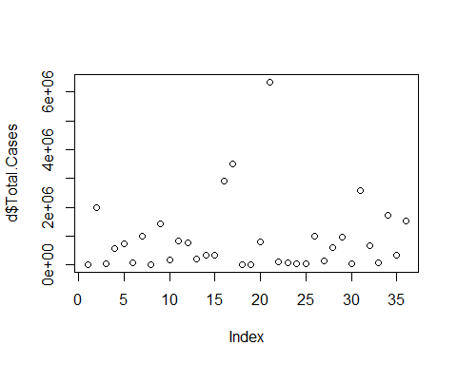

# dimention of dataset  
print(dim(d))

## [1] 36 8

# column names of the dataset  
print(names(d))

## [1] "State" "Total.Cases"   
## [3] "Active" "Discharged"   
## [5] "Deaths" "Total.vaccination.doses"  
## [7] "Dose.1" "Dose.2"

# details of death  
print(d$Deaths)

## [1] 129 13490 237 5357 9646 811 13536 4 25065 3157  
## [11] 10077 9647 3533 4386 5130 36741 17515 207 50 10514  
## [21] 133717 1628 1147 161 582 6302 1799 16312 8954 352  
## [31] 34260 3819 766 22771 7367 18202

# length of the dataset  
print(length(d$Active))

## [1] 36

# structure of the dataset  
print(str(d))

## 'data.frame': 36 obs. of 8 variables:  
## $ State : chr "Andaman And Nicobar" "Andhra Pradesh" "Arunachal Pradesh" "Assam" ...  
## $ Total.Cases : int 7541 1978350 49668 572546 725122 61970 1002958 10652 1436623 171705 ...  
## $ Active : int 4 20593 3032 11719 357 27 1780 12 516 992 ...  
## $ Discharged : int 7408 1944267 46399 555470 715119 61132 987642 10636 1411042 167556 ...  
## $ Deaths : int 129 13490 237 5357 9646 811 13536 4 25065 3157 ...  
## $ Total.vaccination.doses: int 308179 23390769 868372 12089630 26796305 892796 12448461 653551 10559677 1370190 ...  
## $ Dose.1 : int 214334 17319963 685988 9977914 22501851 679894 9900079 576133 7684071 1081299 ...  
## $ Dose.2 : int 93845 6070806 182384 2111716 4294454 212902 2548382 77418 2875606 288891 ...  
## NULL

# glimpse of the dataset  
print(glimpse(d))

## Rows: 36  
## Columns: 8  
## $ State <chr> "Andaman And Nicobar", "Andhra Pradesh", "Arun~  
## $ Total.Cases <int> 7541, 1978350, 49668, 572546, 725122, 61970, 1~  
## $ Active <int> 4, 20593, 3032, 11719, 357, 27, 1780, 12, 516,~  
## $ Discharged <int> 7408, 1944267, 46399, 555470, 715119, 61132, 9~  
## $ Deaths <int> 129, 13490, 237, 5357, 9646, 811, 13536, 4, 25~  
## $ Total.vaccination.doses <int> 308179, 23390769, 868372, 12089630, 26796305, ~  
## $ Dose.1 <int> 214334, 17319963, 685988, 9977914, 22501851, 6~  
## $ Dose.2 <int> 93845, 6070806, 182384, 2111716, 4294454, 2129~  
## State Total.Cases Active Discharged  
## 1 Andaman And Nicobar 7541 4 7408  
## 2 Andhra Pradesh 1978350 20593 1944267  
## 3 Arunachal Pradesh 49668 3032 46399  
## 4 Assam 572546 11719 555470  
## 5 Bihar 725122 357 715119  
## 6 Chandigarh 61970 27 61132  
## 7 Chhattisgarh 1002958 1780 987642  
## 8 Dadra And Nagar Haveli And Daman And Diu 10652 12 10636  
## 9 Delhi 1436623 516 1411042  
## 10 Goa 171705 992 167556  
## 11 Gujarat 825001 204 814720  
## 12 Haryana 770042 690 759705  
## 13 Himachal Pradesh 207344 1727 202084  
## 14 Jammu And Kashmir 322286 1404 316496  
## 15 Jharkhand 347336 226 341980  
## 16 Karnataka 2915317 24354 2854222  
## 17 Kerala 3513551 178722 3317314  
## 18 Ladakh 20378 65 20106  
## 19 Lakshadweep 10243 68 10125  
## 20 Madhya Pradesh 791937 158 781265  
## 21 Maharashtra 6341759 77905 6130137  
## 22 Manipur 102889 8367 92894  
## 23 Meghalaya 68107 5515 61445  
## 24 Mizoram 43530 12869 30500  
## 25 Nagaland 28445 1370 26493  
## 26 Odisha 984731 11501 966928  
## 27 Puducherry 121421 872 118750  
## 28 Punjab 599365 473 582580  
## 29 Rajasthan 953793 233 944606  
## 30 Sikkim 27652 3250 24050  
## 31 Tamil Nadu 2571383 20185 2516938  
## 32 Telengana 648388 8674 635895  
## 33 Tripura 79948 2515 76667  
## 34 Uttar Pradesh 1708689 619 1685299  
## 35 Uttarakhand 342336 513 334456  
## 36 West Bengal 1532379 10642 1503535  
## Deaths Total.vaccination.doses Dose.1 Dose.2  
## 1 129 308179 214334 93845  
## 2 13490 23390769 17319963 6070806  
## 3 237 868372 685988 182384  
## 4 5357 12089630 9977914 2111716  
## 5 9646 26796305 22501851 4294454  
## 6 811 892796 679894 212902  
## 7 13536 12448461 9900079 2548382  
## 8 4 653551 576133 77418  
## 9 25065 10559677 7684071 2875606  
## 10 3157 1370190 1081299 288891  
## 11 10077 35631476 26979294 8652182  
## 12 9647 12654504 9866525 2787979  
## 13 3533 5502831 4155025 1347806  
## 14 4386 6603777 5175592 1428185  
## 15 5130 10094104 8159801 1934303  
## 16 36741 32350283 25190326 7159957  
## 17 17515 21560622 15231555 6329067  
## 18 207 257551 188226 69325  
## 19 50 67491 50772 16719  
## 20 10514 34238893 28719654 5519239  
## 21 133717 46376886 34530719 11846167  
## 22 1628 1379355 1146080 233275  
## 23 1147 1149142 927352 221790  
## 24 161 855488 651442 204046  
## 25 582 785513 629122 156391  
## 26 6302 17714962 13596312 4118650  
## 27 1799 741733 592209 149524  
## 28 16312 10057356 7046711 3010645  
## 29 8954 34620726 26474741 8145985  
## 30 352 647540 496921 150619  
## 31 34260 24821006 20257346 4563660  
## 32 3819 15377071 11548293 3828778  
## 33 766 3200186 2402133 798053  
## 34 22771 53295533 44974649 8320884  
## 35 7367 6424330 4882205 1542125  
## 36 18202 31775426 22747208 9028218

# check unique values  
print(unique(d))

## State Total.Cases Active Discharged  
## 1 Andaman And Nicobar 7541 4 7408  
## 2 Andhra Pradesh 1978350 20593 1944267  
## 3 Arunachal Pradesh 49668 3032 46399  
## 4 Assam 572546 11719 555470  
## 5 Bihar 725122 357 715119  
## 6 Chandigarh 61970 27 61132  
## 7 Chhattisgarh 1002958 1780 987642  
## 8 Dadra And Nagar Haveli And Daman And Diu 10652 12 10636  
## 9 Delhi 1436623 516 1411042  
## 10 Goa 171705 992 167556  
## 11 Gujarat 825001 204 814720  
## 12 Haryana 770042 690 759705  
## 13 Himachal Pradesh 207344 1727 202084  
## 14 Jammu And Kashmir 322286 1404 316496  
## 15 Jharkhand 347336 226 341980  
## 16 Karnataka 2915317 24354 2854222  
## 17 Kerala 3513551 178722 3317314  
## 18 Ladakh 20378 65 20106  
## 19 Lakshadweep 10243 68 10125  
## 20 Madhya Pradesh 791937 158 781265  
## 21 Maharashtra 6341759 77905 6130137  
## 22 Manipur 102889 8367 92894  
## 23 Meghalaya 68107 5515 61445  
## 24 Mizoram 43530 12869 30500  
## 25 Nagaland 28445 1370 26493  
## 26 Odisha 984731 11501 966928  
## 27 Puducherry 121421 872 118750  
## 28 Punjab 599365 473 582580  
## 29 Rajasthan 953793 233 944606  
## 30 Sikkim 27652 3250 24050  
## 31 Tamil Nadu 2571383 20185 2516938  
## 32 Telengana 648388 8674 635895  
## 33 Tripura 79948 2515 76667  
## 34 Uttar Pradesh 1708689 619 1685299  
## 35 Uttarakhand 342336 513 334456  
## 36 West Bengal 1532379 10642 1503535  
## Deaths Total.vaccination.doses Dose.1 Dose.2  
## 1 129 308179 214334 93845  
## 2 13490 23390769 17319963 6070806  
## 3 237 868372 685988 182384  
## 4 5357 12089630 9977914 2111716  
## 5 9646 26796305 22501851 4294454  
## 6 811 892796 679894 212902  
## 7 13536 12448461 9900079 2548382  
## 8 4 653551 576133 77418  
## 9 25065 10559677 7684071 2875606  
## 10 3157 1370190 1081299 288891  
## 11 10077 35631476 26979294 8652182  
## 12 9647 12654504 9866525 2787979  
## 13 3533 5502831 4155025 1347806  
## 14 4386 6603777 5175592 1428185  
## 15 5130 10094104 8159801 1934303  
## 16 36741 32350283 25190326 7159957  
## 17 17515 21560622 15231555 6329067  
## 18 207 257551 188226 69325  
## 19 50 67491 50772 16719  
## 20 10514 34238893 28719654 5519239  
## 21 133717 46376886 34530719 11846167  
## 22 1628 1379355 1146080 233275  
## 23 1147 1149142 927352 221790  
## 24 161 855488 651442 204046  
## 25 582 785513 629122 156391  
## 26 6302 17714962 13596312 4118650  
## 27 1799 741733 592209 149524  
## 28 16312 10057356 7046711 3010645  
## 29 8954 34620726 26474741 8145985  
## 30 352 647540 496921 150619  
## 31 34260 24821006 20257346 4563660  
## 32 3819 15377071 11548293 3828778  
## 33 766 3200186 2402133 798053  
## 34 22771 53295533 44974649 8320884  
## 35 7367 6424330 4882205 1542125  
## 36 18202 31775426 22747208 9028218

# statistical values  
print(is.na(d))

## State Total.Cases Active Discharged Deaths Total.vaccination.doses Dose.1  
## [1,] FALSE FALSE FALSE FALSE FALSE FALSE FALSE  
## [2,] FALSE FALSE FALSE FALSE FALSE FALSE FALSE  
## [3,] FALSE FALSE FALSE FALSE FALSE FALSE FALSE  
## [4,] FALSE FALSE FALSE FALSE FALSE FALSE FALSE  
## [5,] FALSE FALSE FALSE FALSE FALSE FALSE FALSE  
## [6,] FALSE FALSE FALSE FALSE FALSE FALSE FALSE  
## [7,] FALSE FALSE FALSE FALSE FALSE FALSE FALSE  
## [8,] FALSE FALSE FALSE FALSE FALSE FALSE FALSE  
## [9,] FALSE FALSE FALSE FALSE FALSE FALSE FALSE  
## [10,] FALSE FALSE FALSE FALSE FALSE FALSE FALSE  
## [11,] FALSE FALSE FALSE FALSE FALSE FALSE FALSE  
## [12,] FALSE FALSE FALSE FALSE FALSE FALSE FALSE  
## [13,] FALSE FALSE FALSE FALSE FALSE FALSE FALSE  
## [14,] FALSE FALSE FALSE FALSE FALSE FALSE FALSE  
## [15,] FALSE FALSE FALSE FALSE FALSE FALSE FALSE  
## [16,] FALSE FALSE FALSE FALSE FALSE FALSE FALSE  
## [17,] FALSE FALSE FALSE FALSE FALSE FALSE FALSE  
## [18,] FALSE FALSE FALSE FALSE FALSE FALSE FALSE  
## [19,] FALSE FALSE FALSE FALSE FALSE FALSE FALSE  
## [20,] FALSE FALSE FALSE FALSE FALSE FALSE FALSE  
## [21,] FALSE FALSE FALSE FALSE FALSE FALSE FALSE  
## [22,] FALSE FALSE FALSE FALSE FALSE FALSE FALSE  
## [23,] FALSE FALSE FALSE FALSE FALSE FALSE FALSE  
## [24,] FALSE FALSE FALSE FALSE FALSE FALSE FALSE  
## [25,] FALSE FALSE FALSE FALSE FALSE FALSE FALSE  
## [26,] FALSE FALSE FALSE FALSE FALSE FALSE FALSE  
## [27,] FALSE FALSE FALSE FALSE FALSE FALSE FALSE  
## [28,] FALSE FALSE FALSE FALSE FALSE FALSE FALSE  
## [29,] FALSE FALSE FALSE FALSE FALSE FALSE FALSE  
## [30,] FALSE FALSE FALSE FALSE FALSE FALSE FALSE  
## [31,] FALSE FALSE FALSE FALSE FALSE FALSE FALSE  
## [32,] FALSE FALSE FALSE FALSE FALSE FALSE FALSE  
## [33,] FALSE FALSE FALSE FALSE FALSE FALSE FALSE  
## [34,] FALSE FALSE FALSE FALSE FALSE FALSE FALSE  
## [35,] FALSE FALSE FALSE FALSE FALSE FALSE FALSE  
## [36,] FALSE FALSE FALSE FALSE FALSE FALSE FALSE  
## Dose.2  
## [1,] FALSE  
## [2,] FALSE  
## [3,] FALSE  
## [4,] FALSE  
## [5,] FALSE  
## [6,] FALSE  
## [7,] FALSE  
## [8,] FALSE  
## [9,] FALSE  
## [10,] FALSE  
## [11,] FALSE  
## [12,] FALSE  
## [13,] FALSE  
## [14,] FALSE  
## [15,] FALSE  
## [16,] FALSE  
## [17,] FALSE  
## [18,] FALSE  
## [19,] FALSE  
## [20,] FALSE  
## [21,] FALSE  
## [22,] FALSE  
## [23,] FALSE  
## [24,] FALSE  
## [25,] FALSE  
## [26,] FALSE  
## [27,] FALSE  
## [28,] FALSE  
## [29,] FALSE  
## [30,] FALSE  
## [31,] FALSE  
## [32,] FALSE  
## [33,] FALSE  
## [34,] FALSE  
## [35,] FALSE  
## [36,] FALSE

print(is.data.frame(d))

## [1] TRUE

print(is.name(d))

## [1] FALSE

print(ncol(d))

## [1] 8

print(nrow(d))

## [1] 36

print(max(d$Active))

## [1] 178722

print(min(d$Active))

## [1] 4

print(sort(d$Active))

## [1] 4 12 27 65 68 158 204 226 233 357  
## [11] 473 513 516 619 690 872 992 1370 1404 1727  
## [21] 1780 2515 3032 3250 5515 8367 8674 10642 11501 11719  
## [31] 12869 20185 20593 24354 77905 178722

print(which.max(d$Active))

## [1] 17

print(which.min(d$Active))

## [1] 1

print(mean(d$Active))

## [1] 11448.69

print(mean(d$Active,trim=0.10))

## [1] 4370.967

print(var(d$Active))

## [1] 1013732257

print(median(d$Active))

## [1] 1387

print(mad(d$Active))# mean absolute division

## [1] 1957.773

print(sd(d$Active))

## [1] 31839.16

print(mode(d$Active))

## [1] "numeric"

print(range(d$Active))

## [1] 4 178722

print(scale(d$Active))

## [,1]  
## [1,] -0.359453378  
## [2,] 0.287203082  
## [3,] -0.264350373  
## [4,] 0.008489719  
## [5,] -0.348366403  
## [6,] -0.358730997  
## [7,] -0.303673016  
## [8,] -0.359202115  
## [9,] -0.343372553  
## [10,] -0.328422411  
## [11,] -0.353171806  
## [12,] -0.337907585  
## [13,] -0.305337633  
## [14,] -0.315482372  
## [15,] -0.352480833  
## [16,] 0.405328049  
## [17,] 5.253696811  
## [18,] -0.357537498  
## [19,] -0.357443275  
## [20,] -0.354616567  
## [21,] 2.087250440  
## [22,] -0.096789432  
## [23,] -0.186364653  
## [24,] 0.044608760  
## [25,] -0.316550239  
## [26,] 0.001642806  
## [27,] -0.332191354  
## [28,] -0.344723091  
## [29,] -0.352260978  
## [30,] -0.257503459  
## [31,] 0.274388675  
## [32,] -0.087147219  
## [33,] -0.280588238  
## [34,] -0.340137543  
## [35,] -0.343466776  
## [36,] -0.025336547  
## attr(,"scaled:center")  
## [1] 11448.69  
## attr(,"scaled:scale")  
## [1] 31839.16

print(sd(d$Total.Cases/sqrt(length(d$Active))))

## [1] 213699.8

print(max(d$Total.Cases-min(d$Active)))

## [1] 6341755

print(quantile(d$Active))

## 0% 25% 50% 75% 100%   
## 4 326 1387 9166 178722

print(quantile(d$Active,c(0.75)))

## 75%   
## 9166

print(IQR(d$Active))

## [1] 8840

print(t.test(d$Active))

##   
## One Sample t-test  
##   
## data: d$Active  
## t = 2.1575, df = 35, p-value = 0.03792  
## alternative hypothesis: true mean is not equal to 0  
## 95 percent confidence interval:  
## 675.8718 22221.5171  
## sample estimates:  
## mean of x   
## 11448.69

# data visualisation  
  
  
# plotting of total cases  
plot(d$Total.Cases,col="red",xlab="X-axis",ylab="Y-axis",main="total cases")

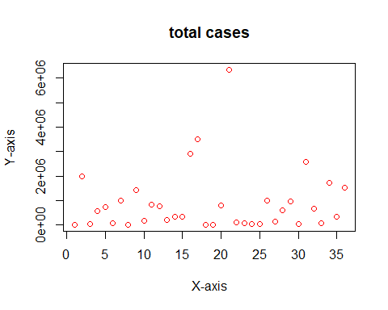

# plotting of total vaccination doses  
plot(d$Total.vaccination.doses,col="red",xlab="X-axis",ylab="Y-axis",main="total vaccination doses taken")

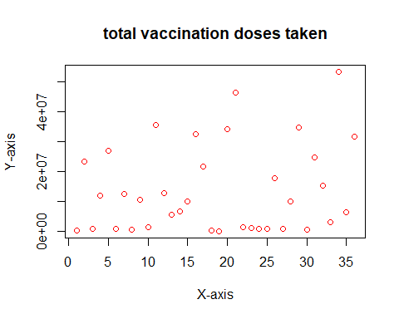

# fisrt dose and second dose vaccination  
plot(x=d$Dose.1,y=d$Dose.2,main="first and second dose vaccines",xlab="dose1",ylab="dose2",col="blue")

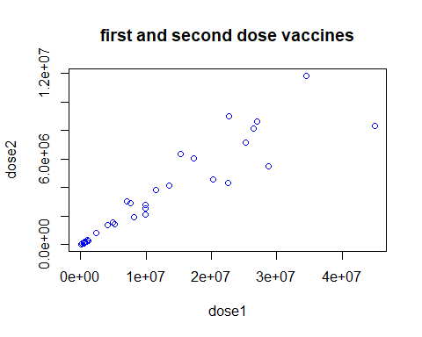

# geographical plot of states releated to total cases  
statewise_totalcase=d %>% group_by(State) %>% summarise(Total.Cases)  
View(statewise_totalcase)  
  
  
# geographical plot of states releated to active cases  
statewise_activecases=d %>% group_by(State) %>% summarise(Active)  
View(statewise_activecases)  
  
  
  
# statewise total vaccination  
statewise_vaccination=d %>% group_by(State) %>% summarise(Total.vaccination.doses) %>% arrange((desc  
 (Total.vaccination.doses)))  
View(statewise_vaccination)  
  
  
# statewise vaccination details(dose1 and dose2)  
statewise_vaccination_doses=d %>% group_by(State) %>% summarise(Dose.1,Dose.2)   
View(statewise_vaccination_doses)  
  
  
# statewise covid details(total,active and discharged cases)  
statewise_details=d %>% group_by(State) %>% summarise(Total.Cases,Active,Discharged)   
View(statewise_details)  
  
  
# statewise dose 1 vaccination using ggplot  
statewisedose1=ggplot(d,aes(x=Dose.1,y=State,fill=Dose.1))+geom_col()  
print(statewisedose1)

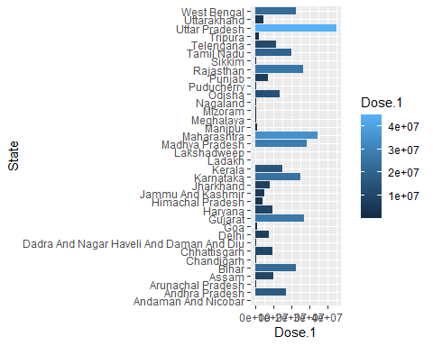

# statewise dose 2 vaccination using bargraph  
statewisedose2=ggplot(d,aes(x=Dose.2,y=State,fill=Dose.2))+geom_col()  
print(statewisedose2)

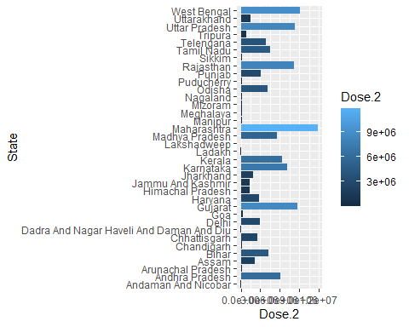

# statewise total vaccination doses using scatter plot  
statewisetotalvaccination=ggplot(d,aes(x=Total.vaccination.doses,y=State,fill=Total.vaccination.doses))+geom_point()  
print(statewisetotalvaccination)

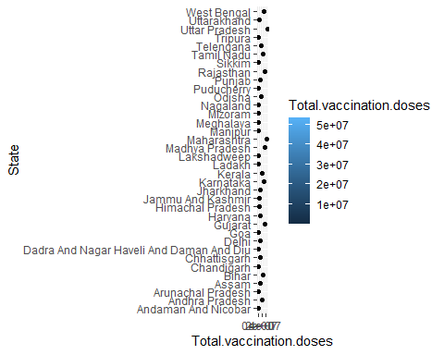

# statewise total cases using scatter plot  
statewisetotalcases=ggplot(d,aes(x=Total.Cases,y=State,fill=Total.Cases))+geom_point()  
print(statewisetotalcases)

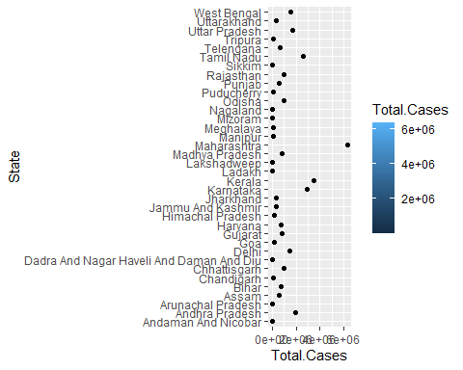

# statewise active cases in dotplot  
statewiseactivecases=ggplot(d,aes(x=Active,y=State,fill=Active))+geom_jitter()  
print(statewiseactivecases)

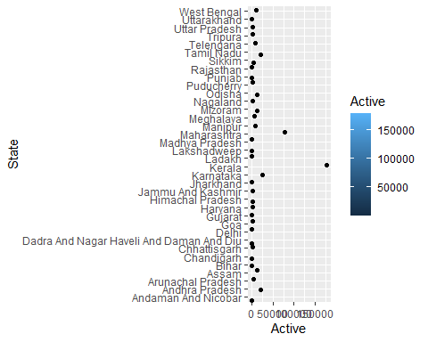

# active cases compared to total cases using lineplot  
totalcases=ggplot(d,aes(x=Active,y=Total.Cases,fill=Active))+geom_line()  
print(totalcases)

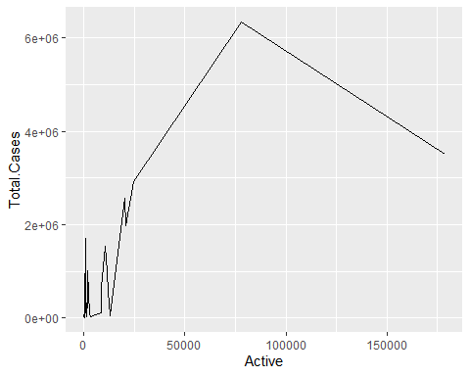

# statewise active cases using boxplot  
totalcases=ggplot(d,aes(x=Active,y=State,fill=Active),size=3.0)+geom_boxplot()  
print(totalcases)

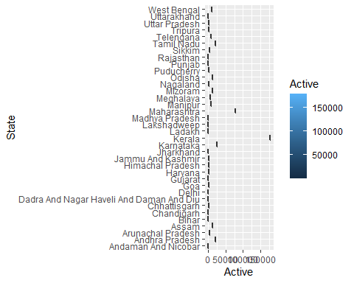

# active cases compared to total cases using barplot  
vaccination<-table(d$Active,d$Total.Cases)  
barplot(vaccination,main='active cases compared to total cases',xlab='totalcases',ylab='active')

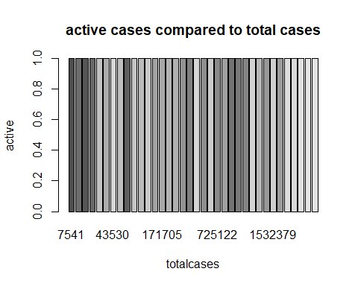

# discharged static using histogram  
hist(d$Discharged,col='steelblue',main='discharged patients',xlab='discharged')

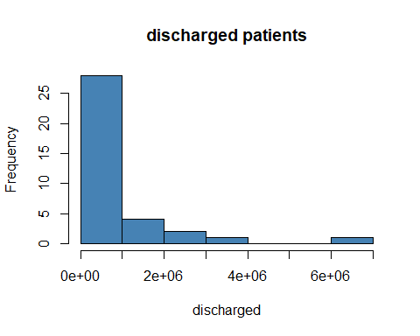

# plotting active cases vs the total cases:  
print(plot(Active~Total.Cases,data=d))

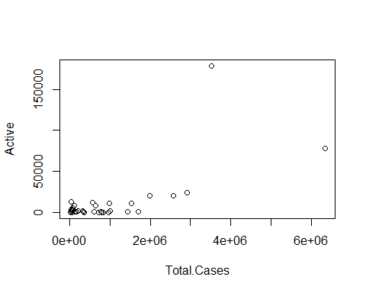

## NULL

# linear regression:  
lr=lm(Active~Total.Cases,data=d)  
print(lr)

##   
## Call:  
## lm(formula = Active ~ Total.Cases, data = d)  
##   
## Coefficients:  
## (Intercept) Total.Cases   
## -3.475e+03 1.684e-02

summary(lr)

##   
## Call:  
## lm(formula = Active ~ Total.Cases, data = d)  
##   
## Residuals:  
## Min 1Q Median 3Q Max   
## -25443 -9834 339 3619 123013   
##   
## Coefficients:  
## Estimate Std. Error t value Pr(>|t|)   
## (Intercept) -3.475e+03 4.831e+03 -0.719 0.477   
## Total.Cases 1.684e-02 3.129e-03 5.383 5.46e-06 ***  
## ---  
## Signif. codes: 0 '***' 0.001 '**' 0.01 '*' 0.05 '.' 0.1 ' ' 1  
##   
## Residual standard error: 23740 on 34 degrees of freedom  
## Multiple R-squared: 0.4602, Adjusted R-squared: 0.4443   
## F-statistic: 28.98 on 1 and 34 DF, p-value: 5.457e-06

par(mfrow=c(1,1))  
plot(lr)

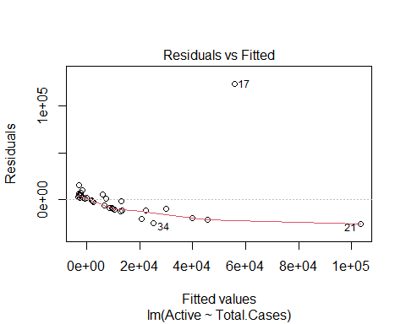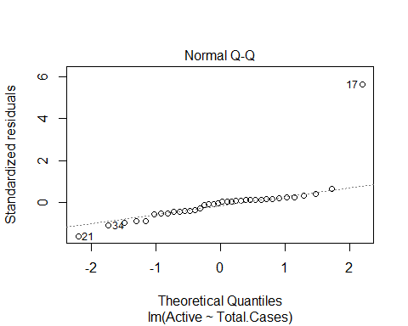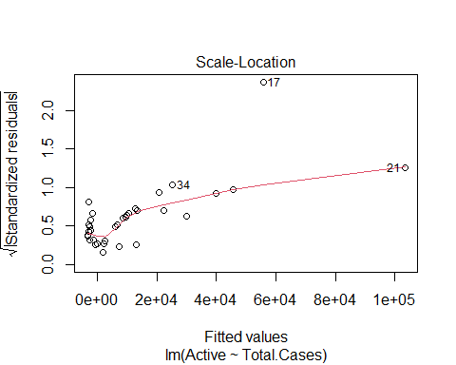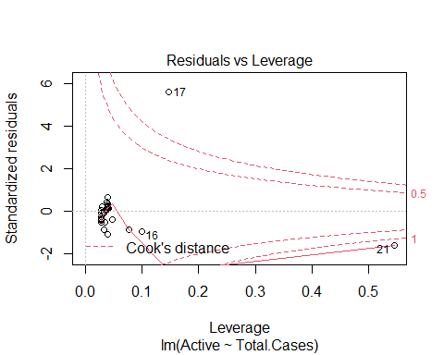

i<-ggplot(d,aes(x=Active,y=Total.Cases))+geom_point()  
print(i)

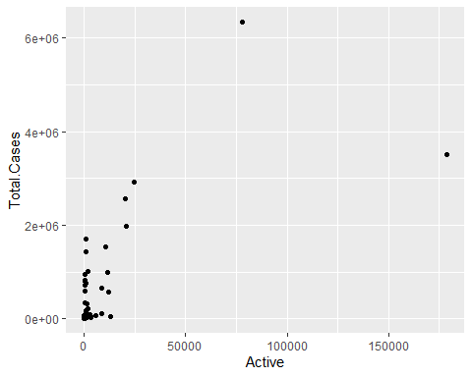

i<-i+geom_smooth(method="lm",col="blue")  
print(i)

## `geom_smooth()` using formula 'y ~ x'

